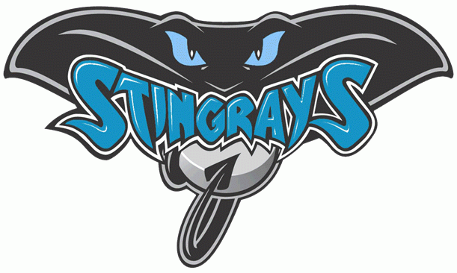
Hilton Head Island Middle School Boys/Girls Basketball 2022/2023
Date Opponent Site Time
11/28 Lady’s Island LIMS 6:00
12/1 Hardeeville HMS 6:00
12/6 Colleton County HHIMS 6:00
12/8 Whale Branch WBMS 6:00
12/12 Bridges Prep HHIMS 6:00
12/15 Ridgeland RMS 6:00
1/9 Beaufort HHIMS 6:00
1/12 McCracken HHIMS 5:30
1/17 Bluffton BLMS 5:30
1/19 Robert Smalls HHIMS 6:00
1/23 River Ridge RRA 5:30
1/26 Playoff TBD 6:00
1/30 Semi-Final TBD 6:00 2/2 Championship TBD 6:00

